COMPLETING A DISTRICT GRANT APPLICATION – STEP BY STEP INSTRUCTIONS
- Log in to DACdb and Click on the My Club tab.
- Click on the Club Grants icon
- In the left-side menu, click on Audit Club Signatures
  - Change the ORGYEAR to 2022-2023 if needed
  - Find the name of your club and click on the name.
  - In the left-side column, select the names of those that you wish to have access to your club grant application and receive notifications regarding the grant. Click on the right facing arrows to move them into the right-side Permissions box.
  - Click Save at the top right corner of the screen.
- In the left-side menu, select Club Grant View
- On the right side of the screen, click on the New Club Grant Request Button to begin the application.
  - New progression bar feature at the top of the screen will be a great resource to show you where your club is at in the Grant process.
  - Under the Details tab, enter all the required information noted with an asterisk (*).
  - If any other clubs are involved in your project, click on the Clubs Involved tab and select the club from the left side menu and move to the right-side column using the right facing arrows. If no other club is involved, you can skip this tab.
  - Under the Contacts tab, select the club members that you want to have access to the grant application and receive notifications regarding the grant. We recommend 2 or more members included to receive notifications about the grant but only require 1 member.
  - Under the Application tab, enter all required information and at the bottom be sure to click on the required Statements.
  - Click Save at the top right corner of the screen to save your application
- You will see additional tabs have been added to the screen: Budget and Documents.
  - Under the Budget tab, click on the Add Income Source
  - Enter a Description for your District Grant Request including the amount and click on
DDF Requested.
- Click Add at the bottom right
  - Next, click on the Add Income Source, and enter the amount of what your club will be contributing to the project and select Other Club Funding. For example, Other Club
Funding $1,500
o Click Add at the bottom right
  - Enter your project expenses by clicking on the ADD Expenses button
- The Budget Summary should have a Zero balance

2022-2023 DGMT 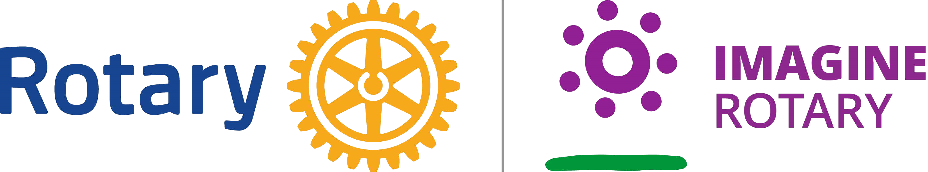 ¹

COMPLETING A DISTRICT GRANT APPLICATION – STEP BY STEP INSTRUCTIONS
- Change the status of the grant and submit it for club approval.
o Click on the Change Status button in the top right corner of the screen.
o In the dropdown menu, select Submit for Club Approval and click Change Status.

- Audit Club Signatures, only members given approval can sign a Grant.
  - When correctly signed, you will see “e/signature” notation.

- Next, you will Change Status to Submit Grant for District Approval.
- Once the District approves the grant, the club receives an email notifying them that they are ready to start working on their project.
- New Expense tab allows you to upload your receipts and track your expenses for the grant project.
- Under the Documents tab, after the project is completed, upload your photos.
- Complete your Final Report. Add your numbers to the final report and Save Grant.
- Submit the Final Report for Club Signatures.
- Submit Final Report to the District for approval.
- The District will approve the final report and update the status to Project Complete.
- Your Club will receive a check.
Additional resources can be found online in the DACdb Grant Module. In the left side menu, under “Getting Started Videos,” you will find Grant Video 1 to be extremely helpful.
All District 6920 District Grant Management Training documents can be on the Rotary District 6920 website, rotarydistrict6920.org, under the Rotary Foundation tab and District Grants.

2022-2023 DGMT 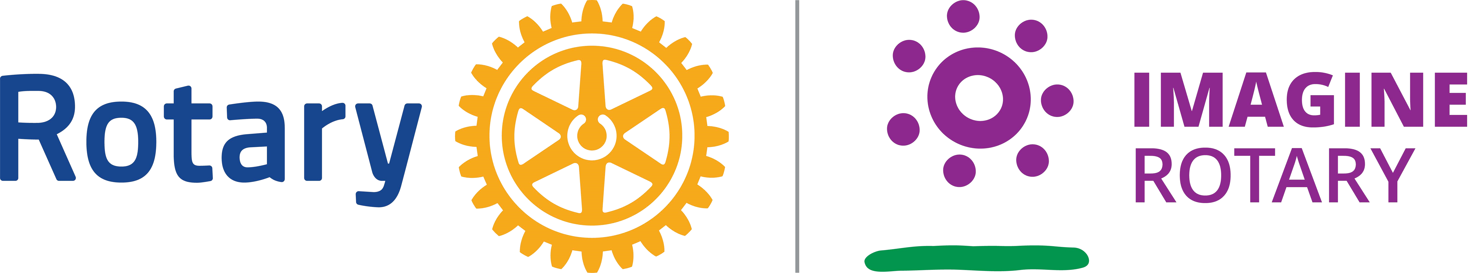 ²

